**QUESTION 2:**

Author ( authorname, citizenship, birthyear)

Book(isbn, title, authorname)

Topic(isbn, subject)

Branch(libname, city)

Instock(isbn, libname, quantity)

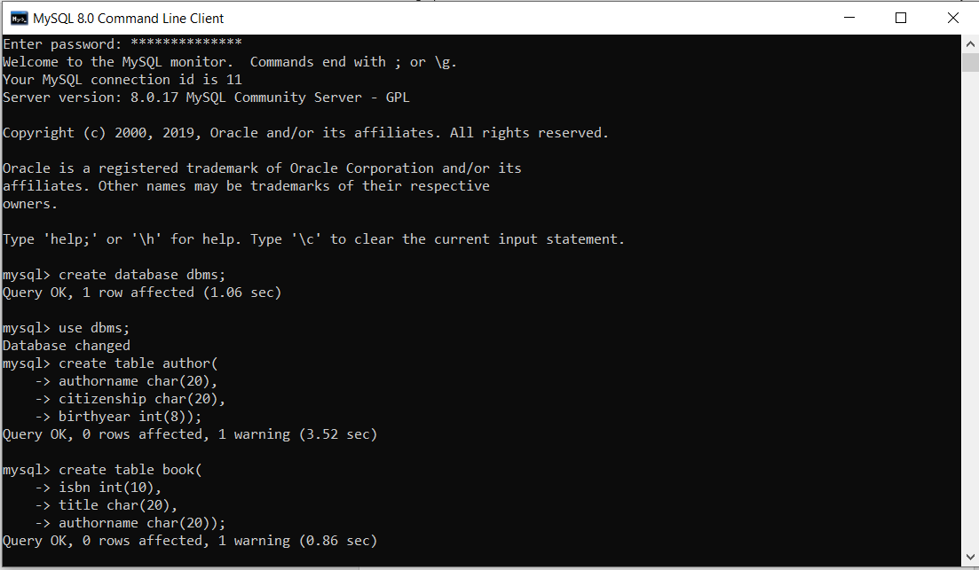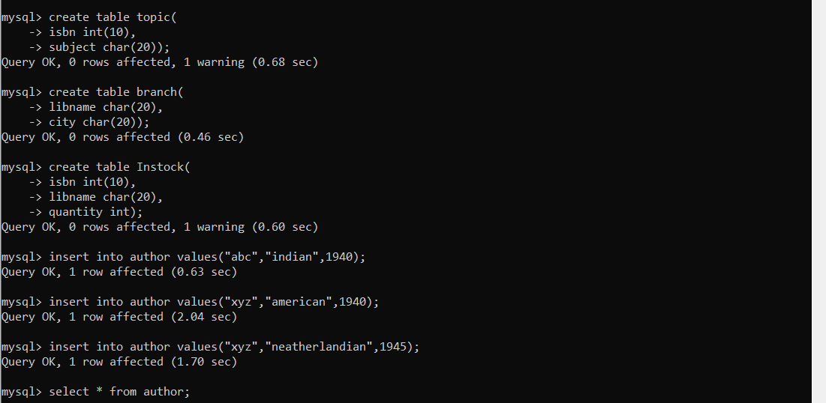

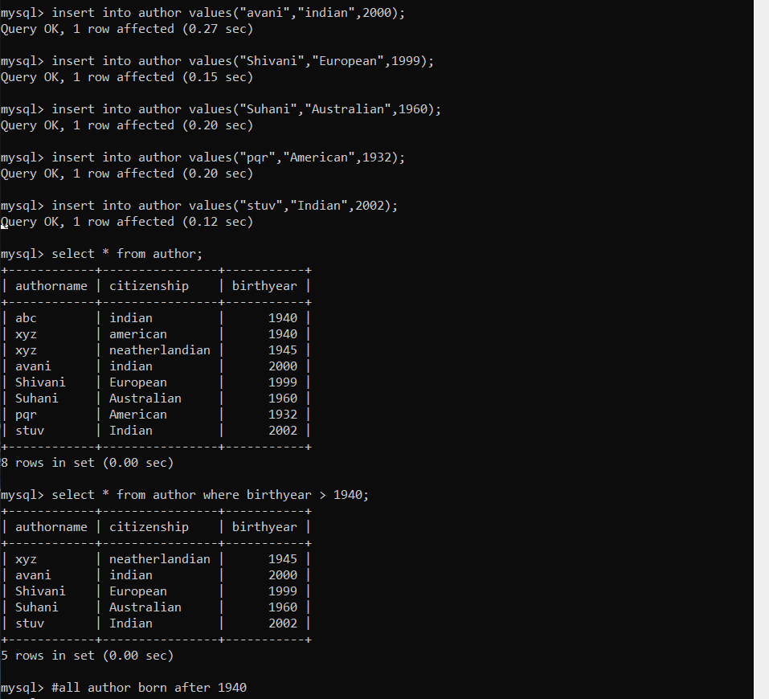



1. Give all authors born after 1940.



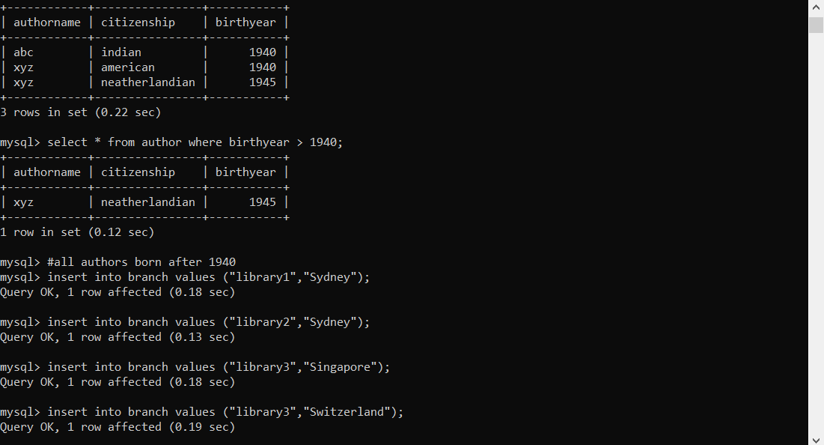

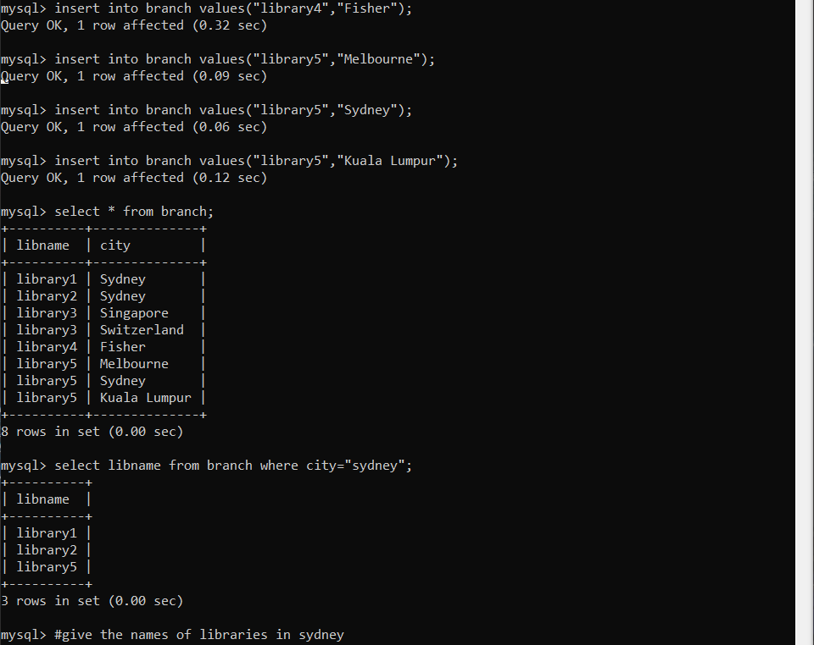

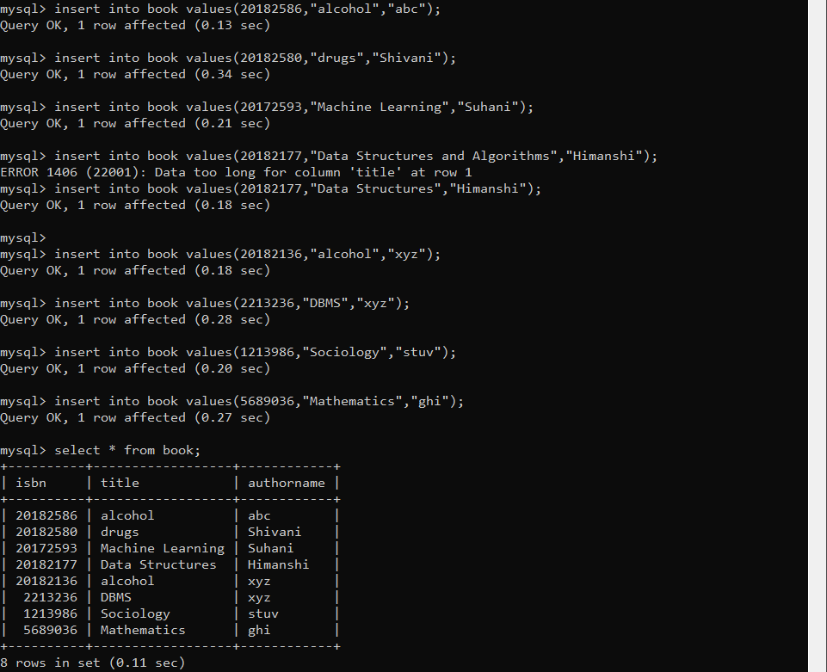



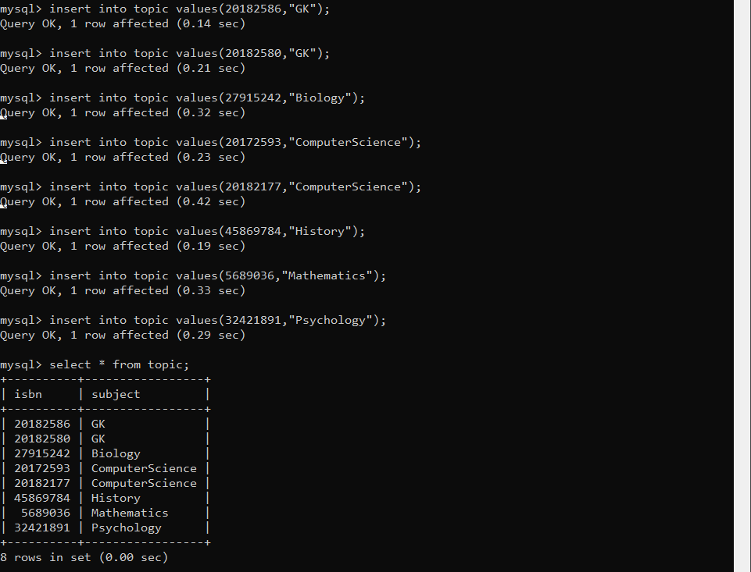



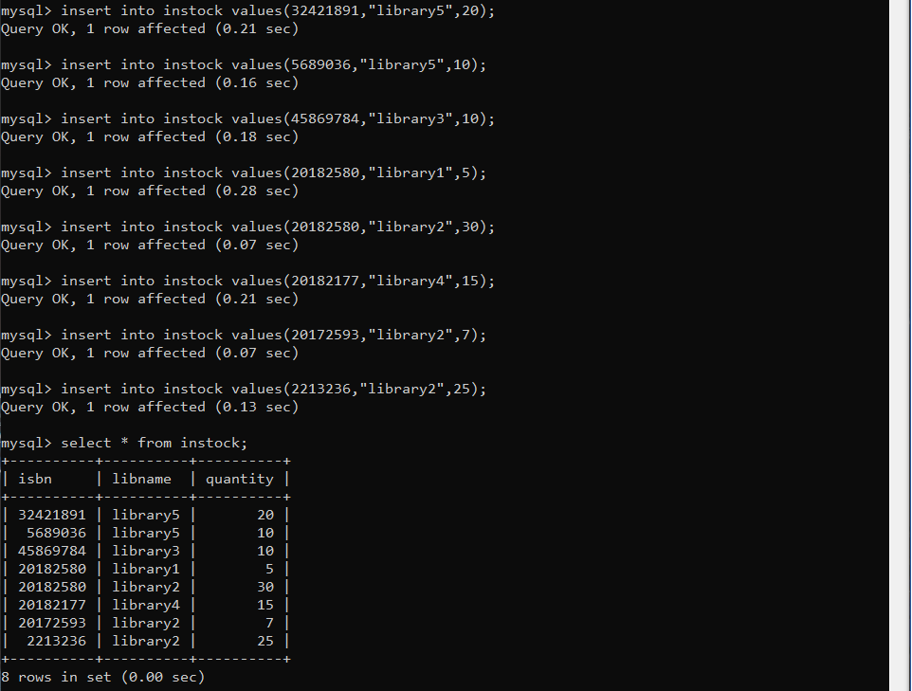



2. Give the names of libraries in Sydney.

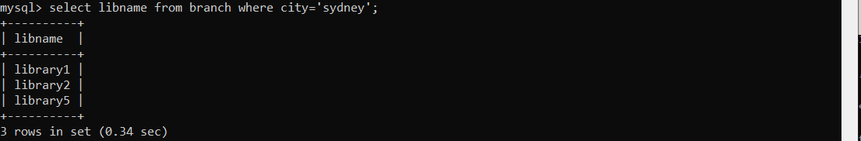

3. Give the cities where each book is held.

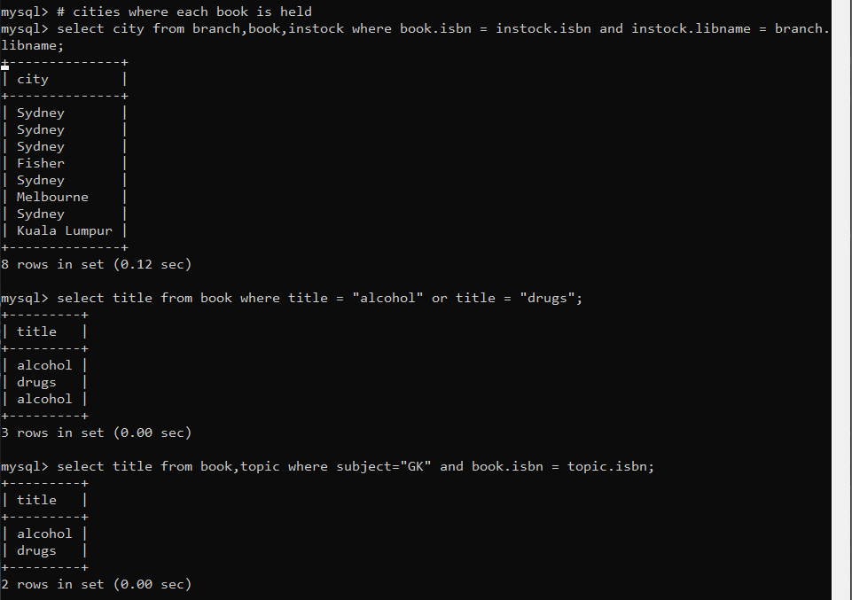

4. Give the title of each book on the topic of either alcohol or drugs.



7. Give the total number of books in stock in the branch called Fisher.

9. Give the total number of books in stock in the branches located in Sydney.

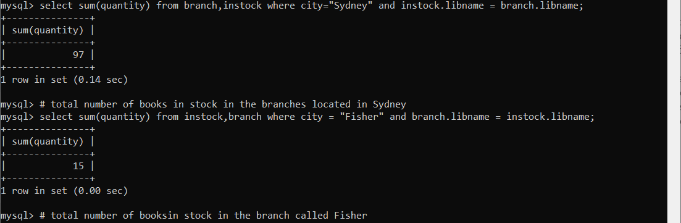

5 Give the title and author of each book of which at least two copies are held in a branch located in Melbourne.

6. Give the name of each Italian author who wrote an autobiography.

8. This could mean the number of different titles, or the number of physical copies.

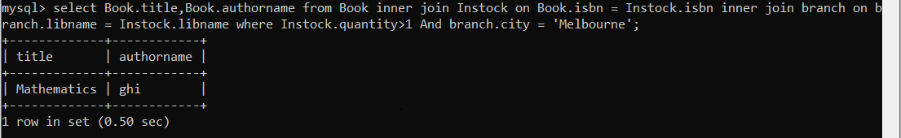



**QUESTION 1:**

Flights(flno, from, to, distance, departs)

Aircraft(aid, aname, range)

Certified(eid, aid)

Employees(eid, ename, salary)

By definition, pilots are those employees who are certified on at least one aircraft. An aircraft can be used for any flight provided it has sufficient range. Pilots can pilot any flight provided they are certified on an aircraft with sufficient range.

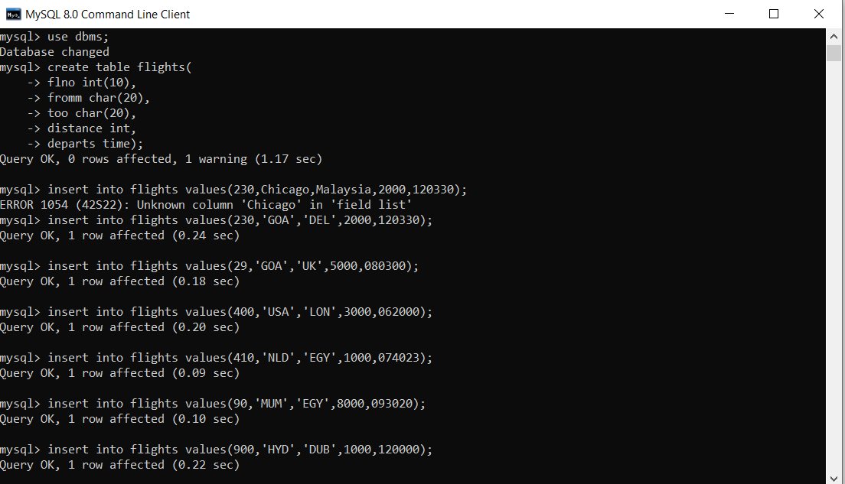

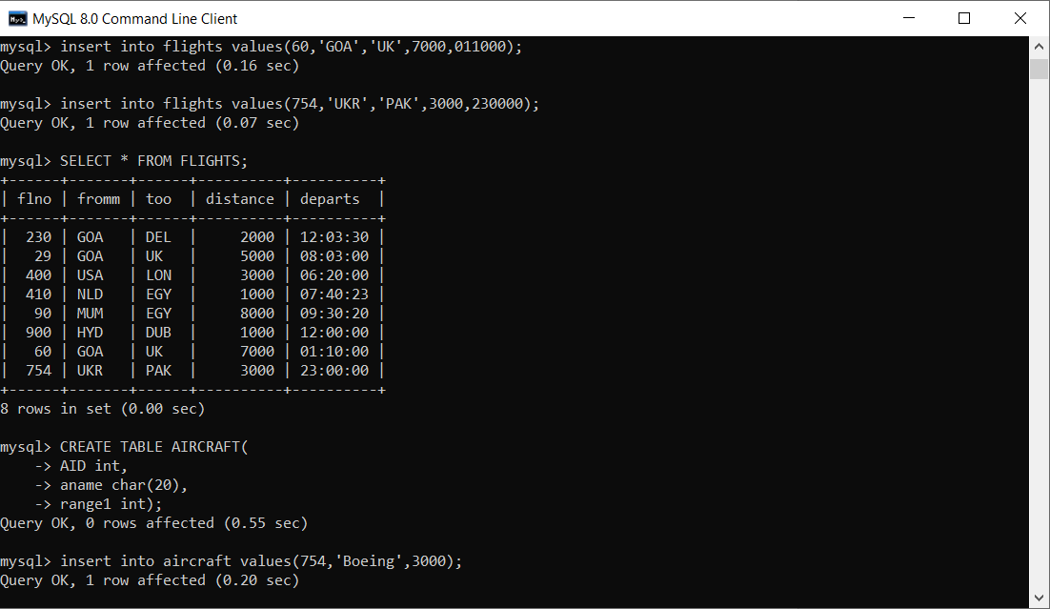

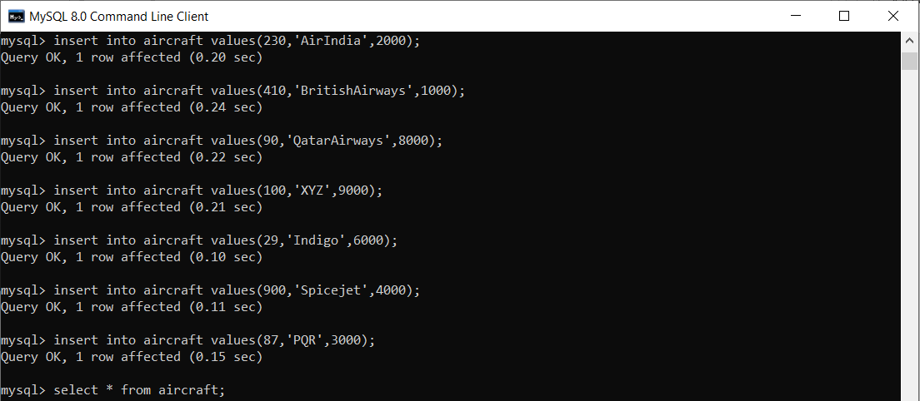

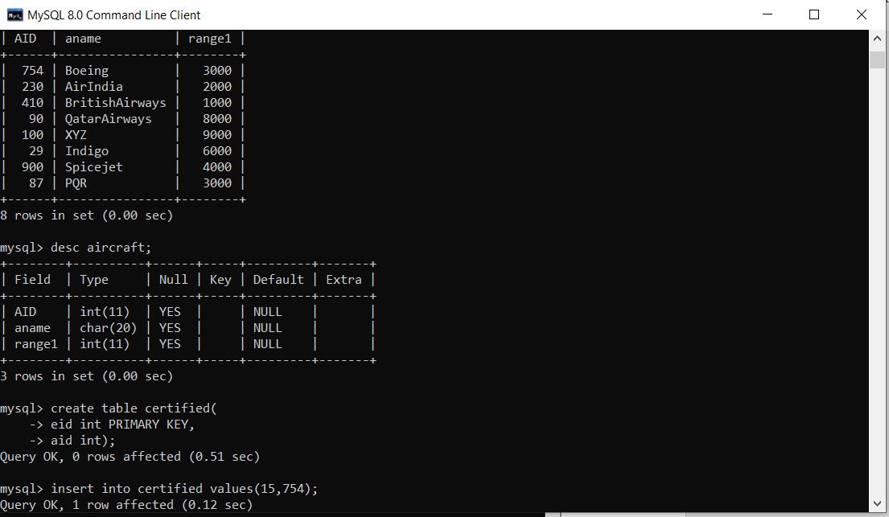

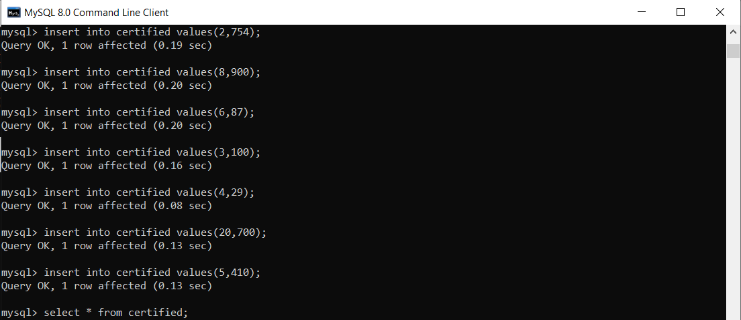

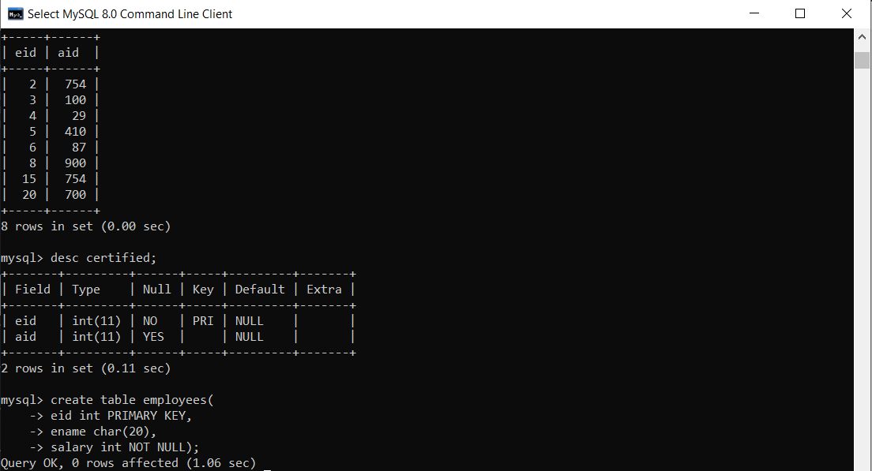

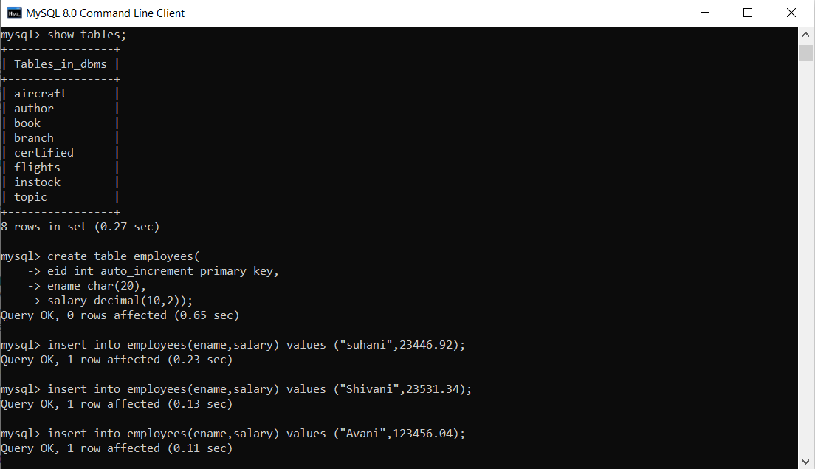

1. Find eid’s of pilots who are certified on some Boeing.

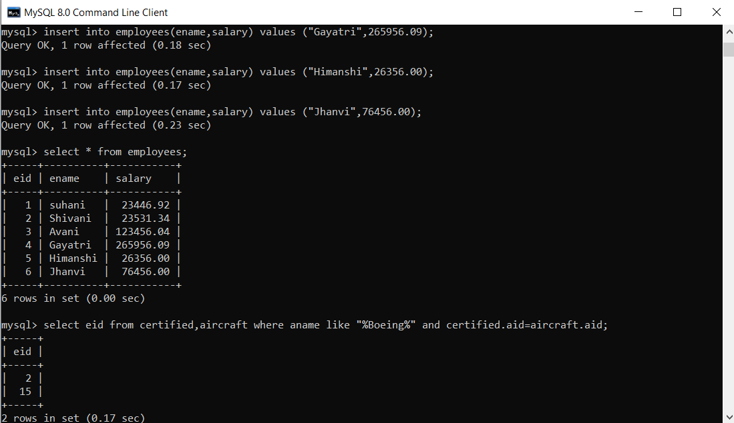

2. Find names of pilots who are certified on some Boeing.

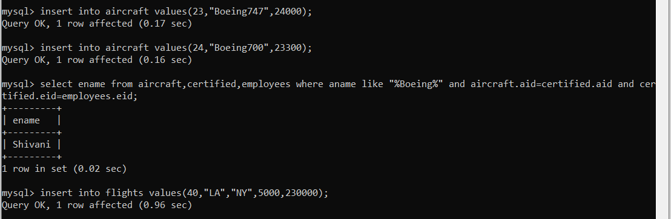

3. Find aid’s of aircraft that can fly non-stop from LA to NY. Assume you don’t already know the distance.

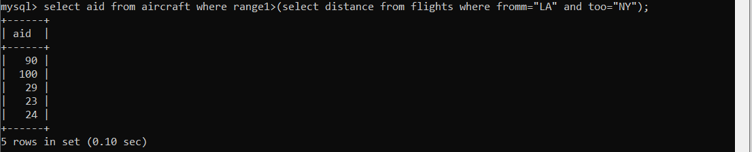

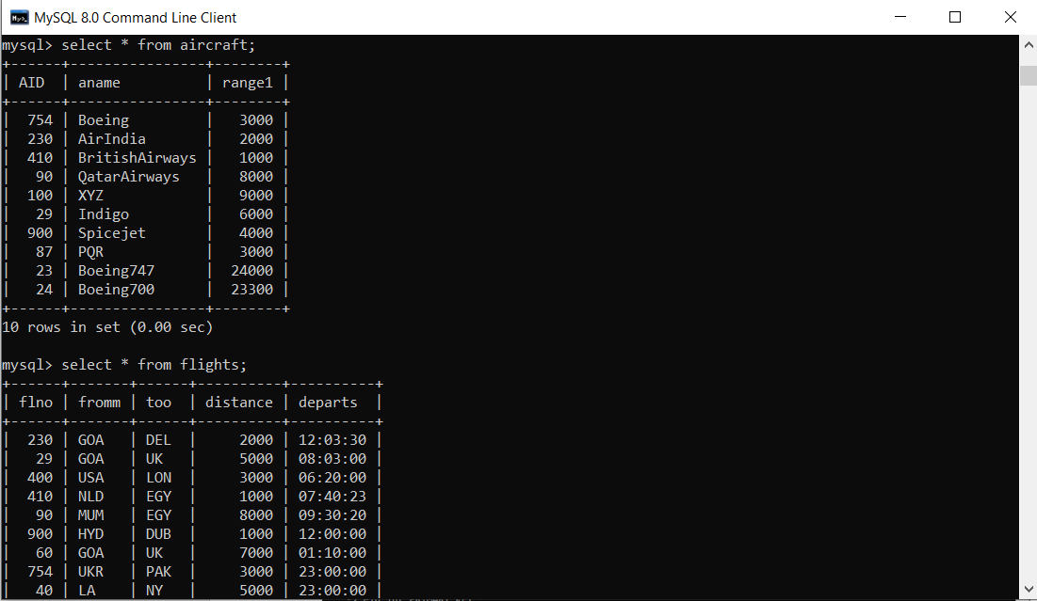

5. Find names of pilots who can operate planes with a range greater than 3,000 miles, but are not certified on any Boeing.

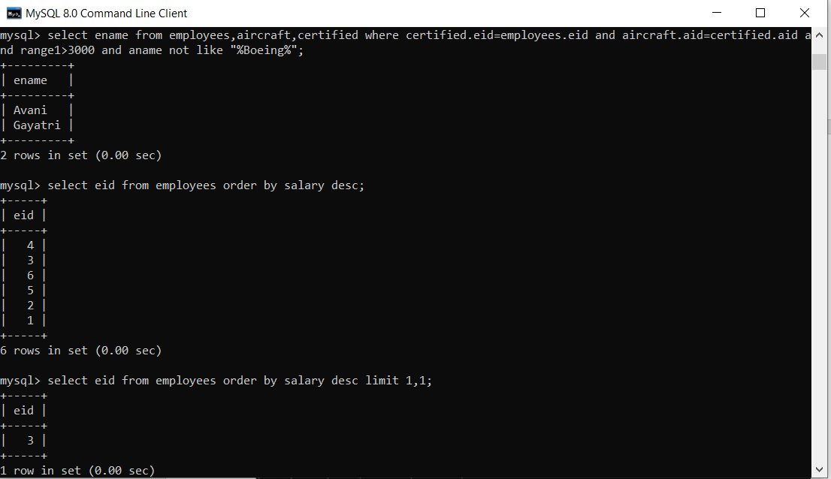

6. Find eid of employee(s) with the highest salary.

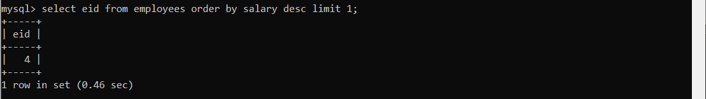

7. Find eid of employee(s) with the second highest salary.



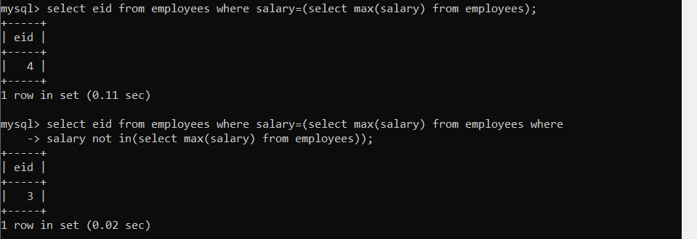

8. Find eid’s of employees certified on exactly three aircraft.

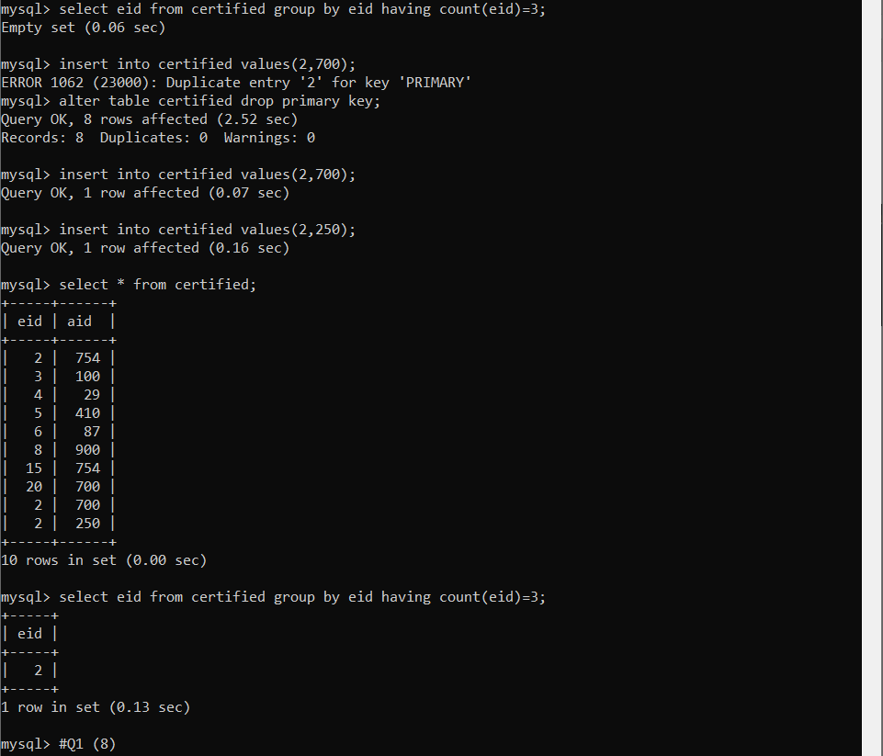

4. Find flno of flights that can be piloted by every pilot whose salary is over $100,000.

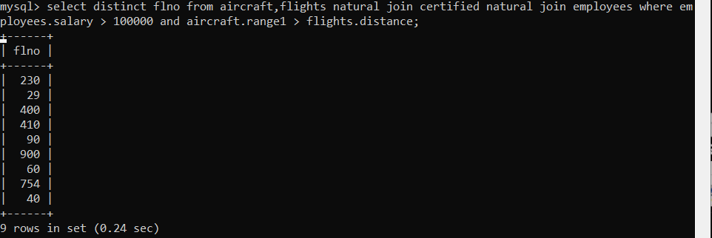

**QUESTION 3:**

Consider a database:

Suppliers(*sid: integer,sname:varchar(10),address: varchar(10),)*

Parts(*pid: integer, pname: varchar(10), color: varchar(10))*

Catalog(*sid: integer, pid: integer, cost: real)*

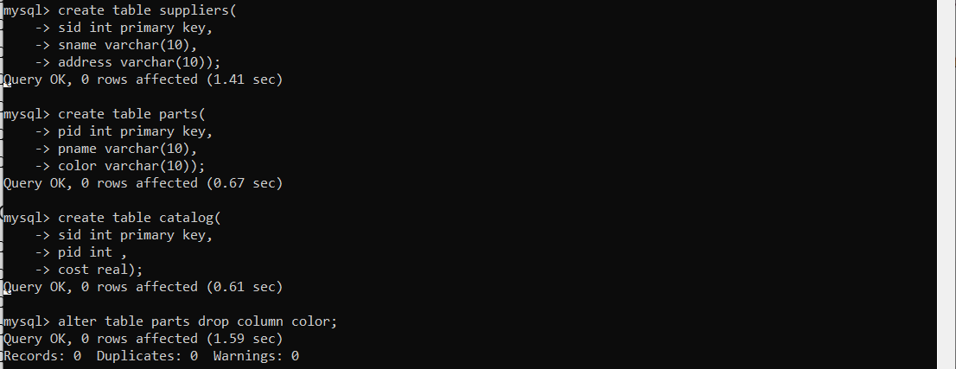

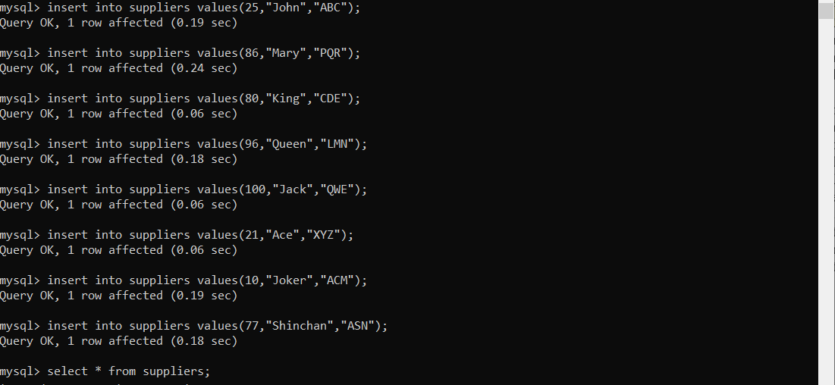

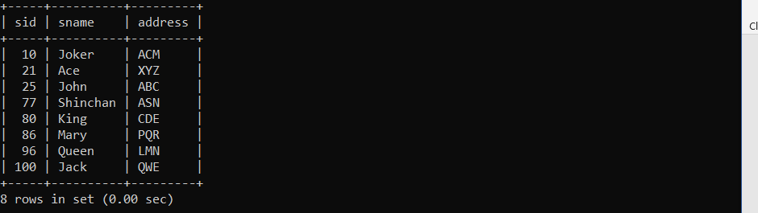

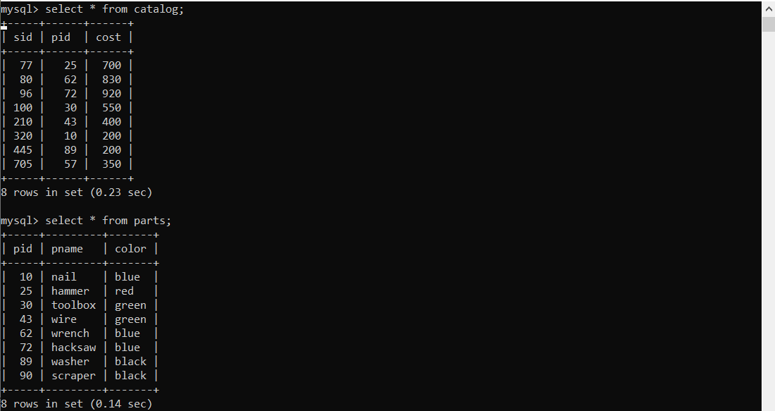

1. After creating the table I realized that I forgot to mention that only green, red, blue and black color parts are allowed in parts relation. Write a query to add this constraint in parts relation.



1. For every supplier that only supplies green parts, print the name of the supplier and the total number of parts that she supplies.
2. Increase the cost of each product by 10% which are green in color and are supplied by supplier = “John”.

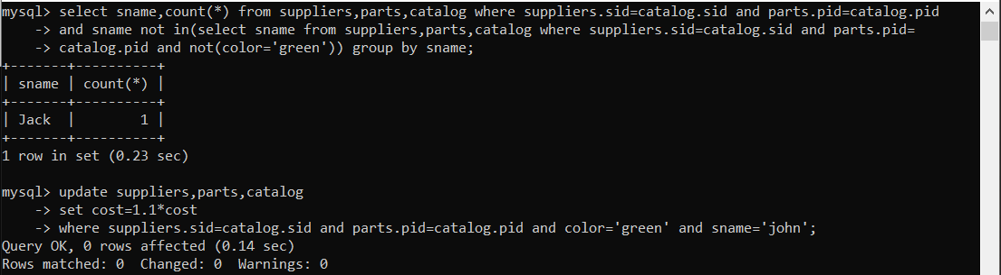

1. Delete all the parts supplied by supplier “King”.
2. Drop the attribute color from parts relation.

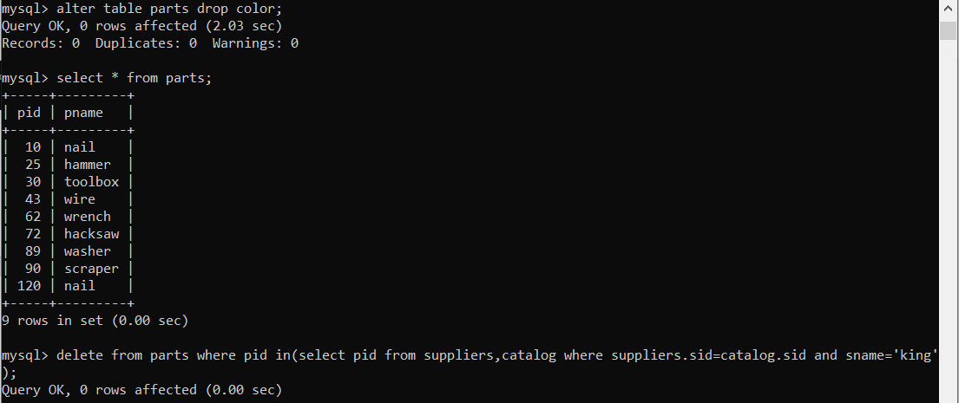

1. Create a view for customers so that they can see only the supplier names, the name of parts supplied by that supplier and their cost.

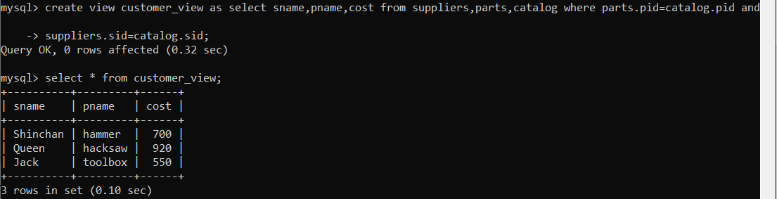

**QUESTION 4**

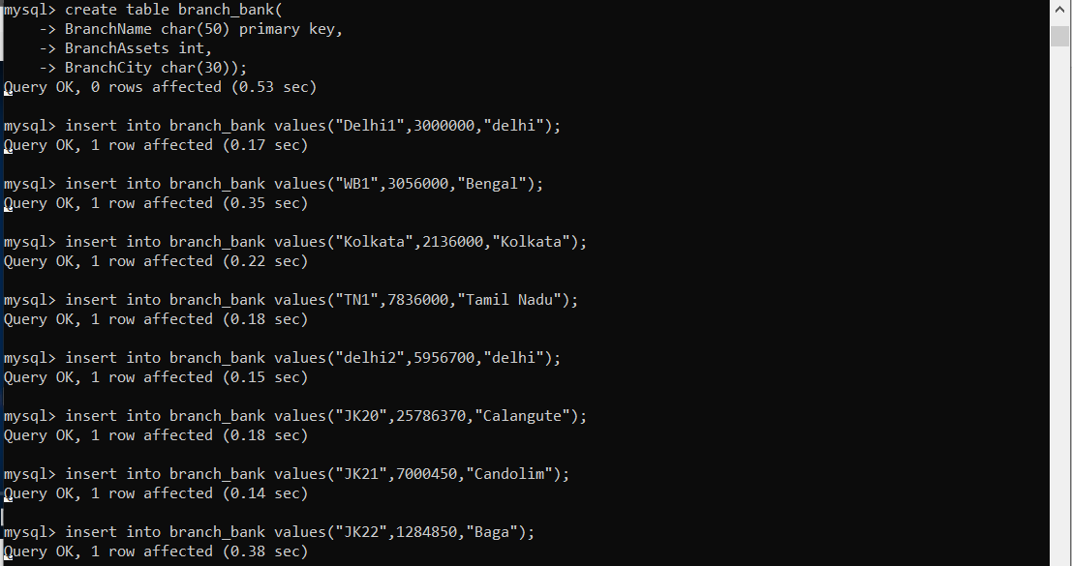

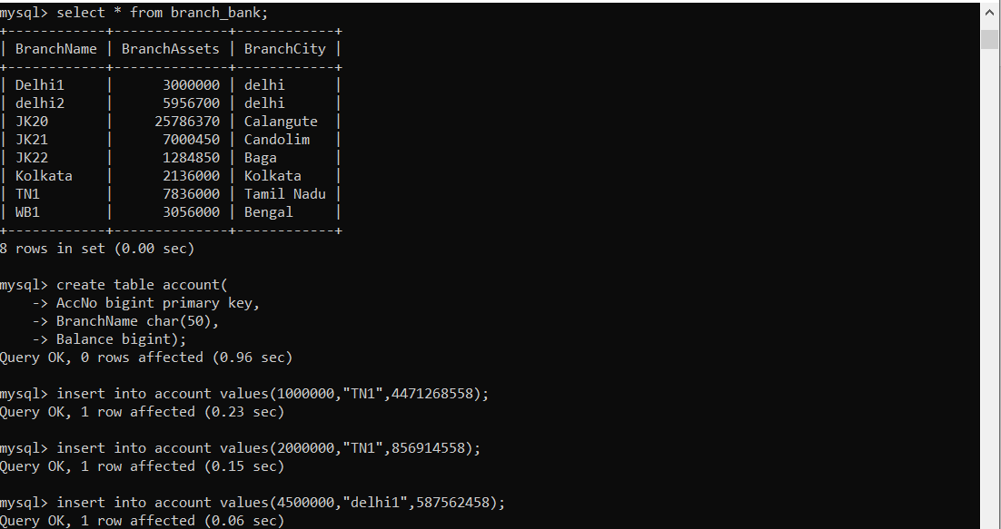

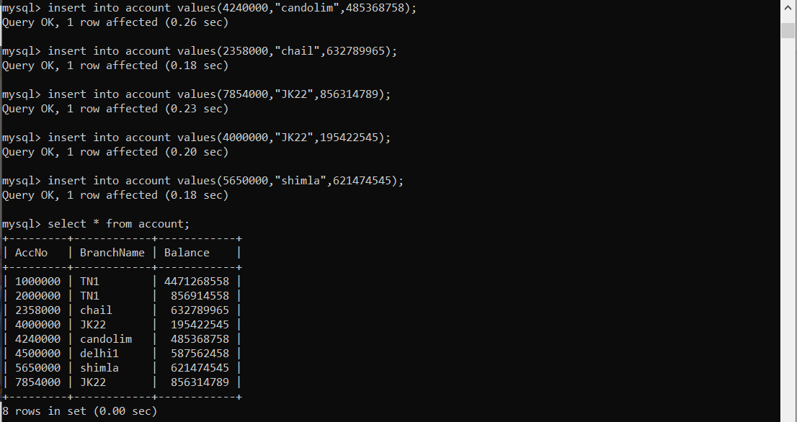

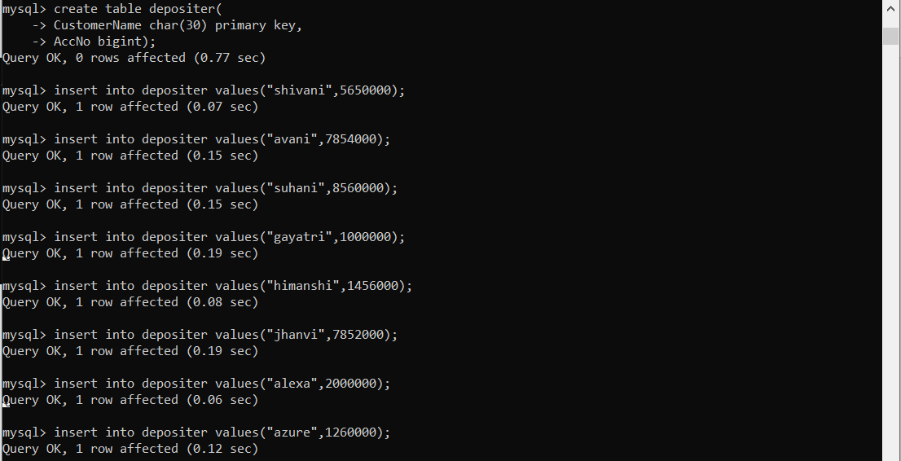

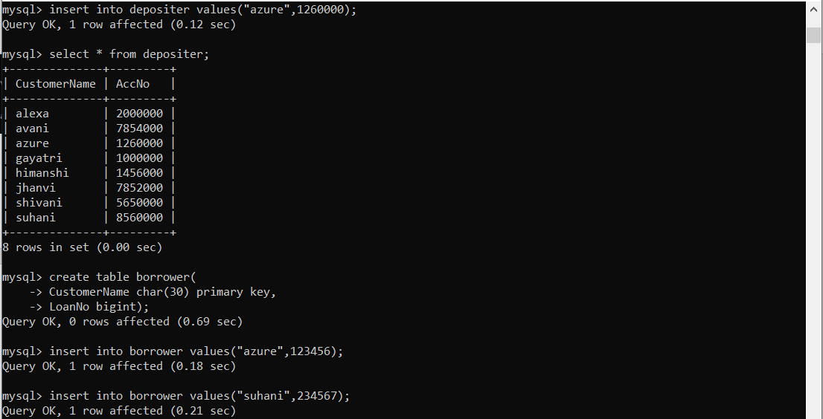

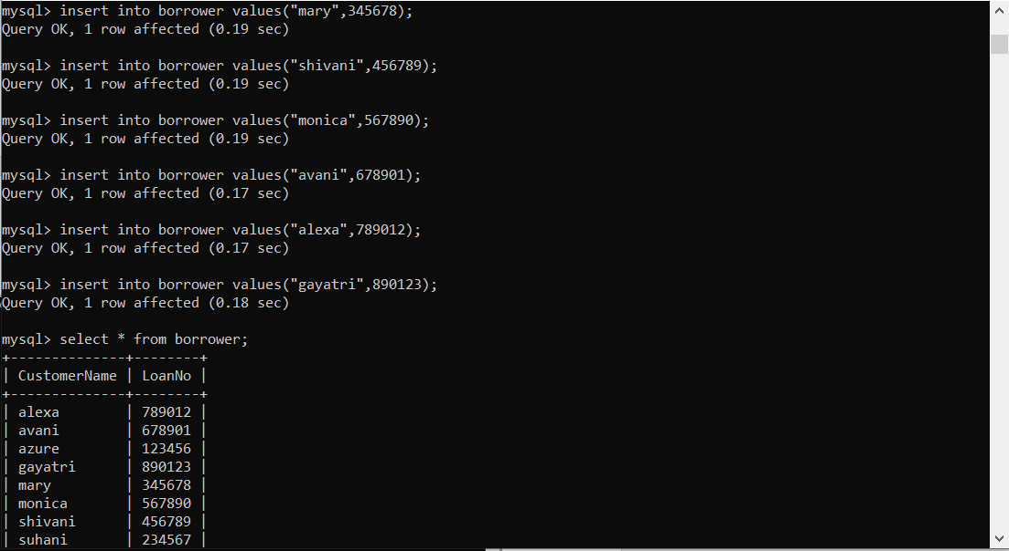

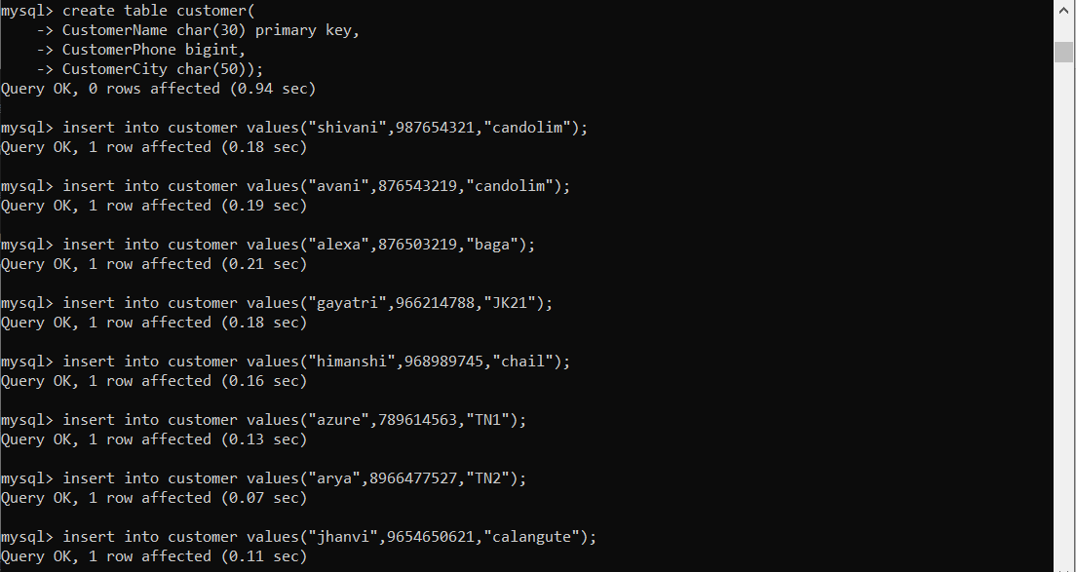



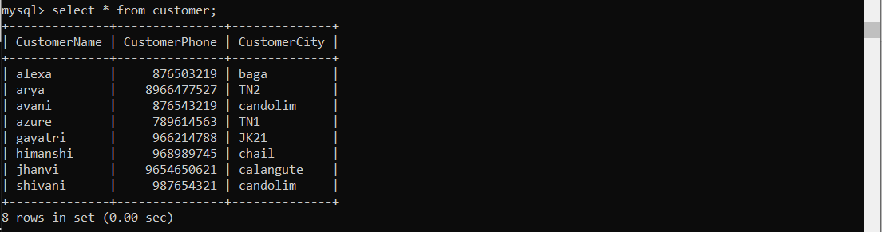

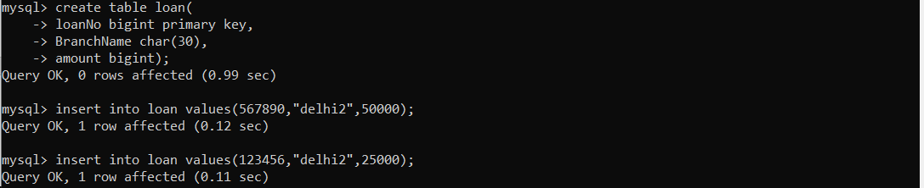





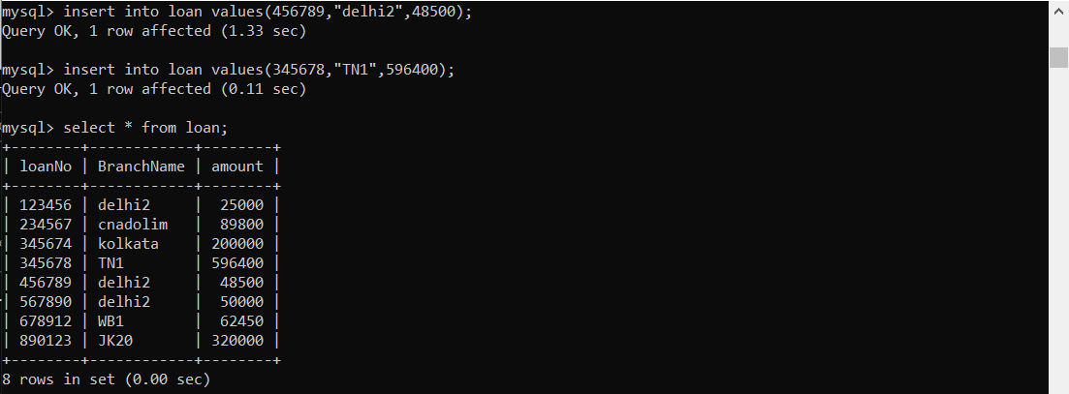

* 1. Find the details of account having balance greater than or equal to 50000.

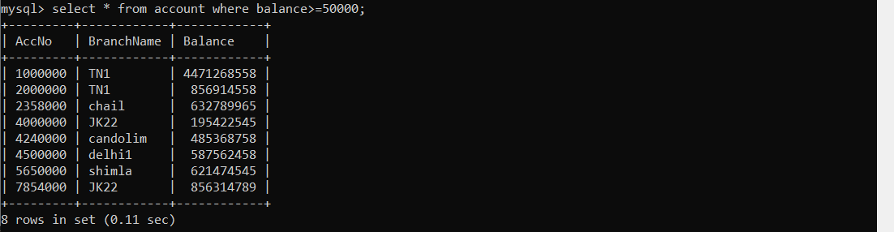

* 1. Find the details of loan having branchname=Delhi and amount<10000.



* 1. Find out the details from branch which is in Delhi or having assets more than 1 crore.

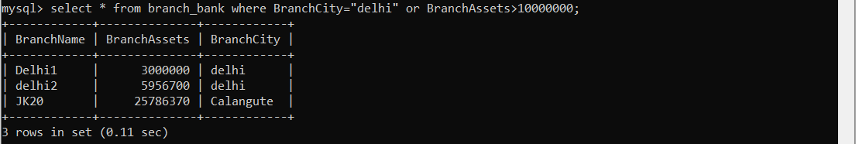

1. Find all branch name of the bank.

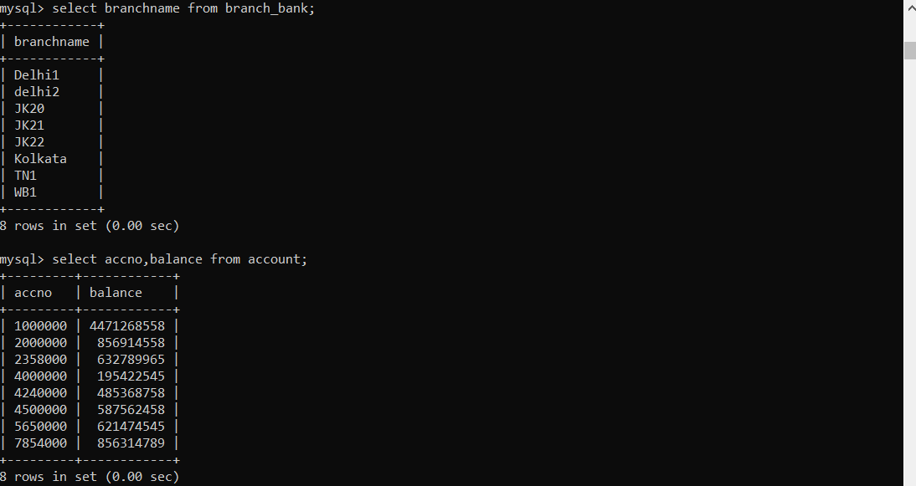

1. Find all Account Number along with their balance.
2. Find the name of all customer who had taken loan.
3. Find all the details about branch.

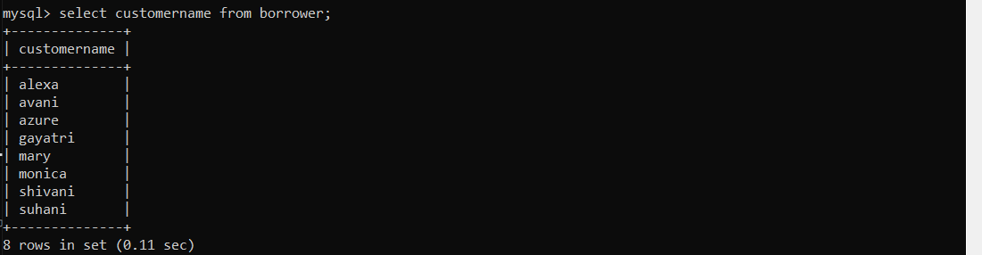

1. Find those loan No which are from Delhi2 branch with amount>1000.

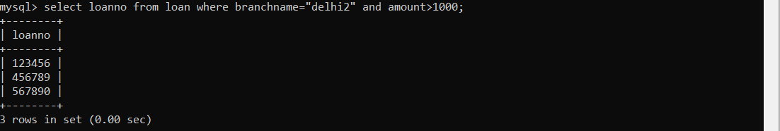

1. Find the names of customer who have taken loan or have account or both.

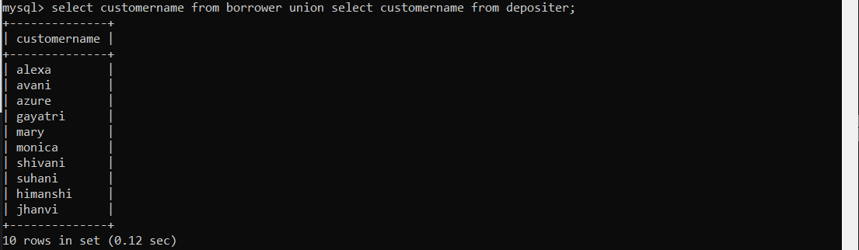

1. Find out the customer names having account balance<100.
2. Find account numbers which are in Delhi.

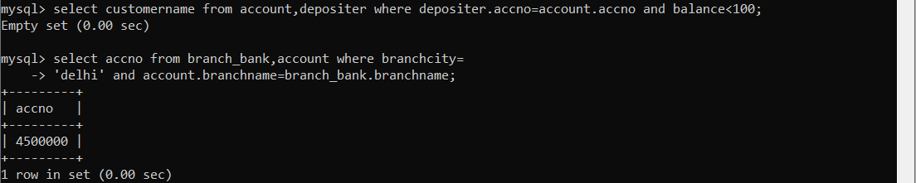

1. Find customer name who have a loan from a branch having assets>10 lakhs.

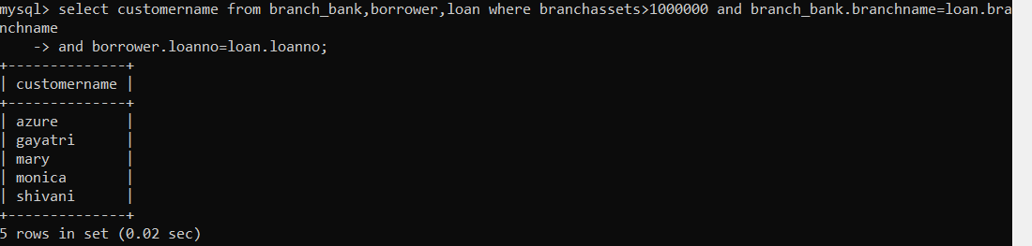

1. Find names of branch who have account not loan.
2. Find names of customer who neither have loan nor have account.

